--

Project title
Gym Fitness and Workout Progress Tracking Portal
Student 1  Registrration No. | Muhammad Hamza khan  2502941
Student 2  Registration No. | Awais Bajwa  2502857
Class | BSSE-II-A
Supervisor | Sir Zulfiqar Ali
Version | 1.0
Degree | Bachelor of science in Software Engineering

Introduction
The gym fitness and workout progress tracking portal is a web-based application that digitally manages gym activities. It allows member to track workouts, diet plans, BMI, and calorie data. Trainers can create personalized workout plans and communicate directly with clients. The system addresses problems such as a lack of trainer communication, poor progress tracking, and difficulty calculating calorie and nutrition intake. It integrates six functional modules into one centralized platform

Modules
- User management- registration, login, profile
- Workout management - plans, tracking, history
- Progress Tracking & Data visualization
- Nutrition & Client Communication
- Exercise Tutorial system

Design Methodology

Design methodology: Object-oriented design(OOD)
The system is built using OOD because the system is organized around distinct entities such as user, member, trainer, workout plan and diet plan. OOD allows modularity and easier maintenance of code. Each module operates independently while sharing common data.

Process Model: Agile
We are following Agile Process because it allows iterative development. We can develop and deliver modules like Login and Calculator first, gather feedback, then refine the Trainer Chat and Progress Tracking modules. Agile suits this project as requirement may evolve based on user need and feedback.

System Overview
The gym fitness and workout progress tracking portal is a web based application designed to help gym members manage their fitness activities digitally. It provides features including workout plan management , BMI calculation , nutrition tracking , progress visualization through graph , trainer-client messaging and exercises tutorial videos. The system uses HTML , CSS , JavaScript for the front end in VS-code, and SQL database for backend data management.

Architectural design
The system follows a layered architectural consisting of three layers :
- Presentation layer(UI)
- Business logic layer (backend logic behind system)
- Data layer

Presentation layer

It handles all graphical user interface that interacts with user directly

- Business layer
It handles and processes coming request such as BMI calculation and workout assignment
- Data layer
It manages SQL database to store all data

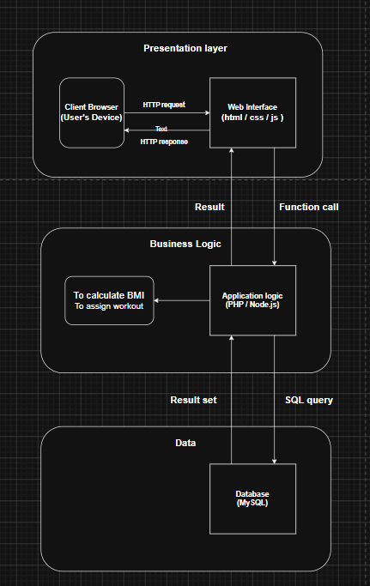
- The client browsers sends an HTTP request to Web interface that receives it
- The web interface passes the data via a function call ( like a function does math and returns an answer) to the application logic to process it (BMI calculator and workout assignment)
- The data is stored in MySQL database and returns all the way to the user’s device

Design models

Client user case diagram

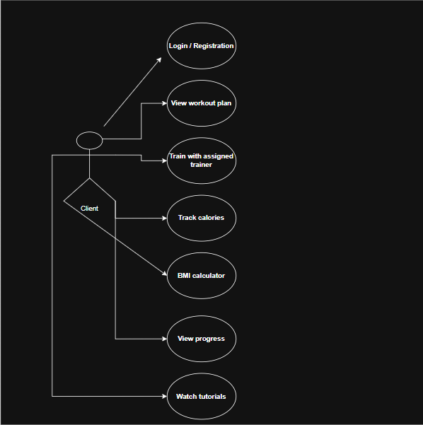

Trainer user case diagram

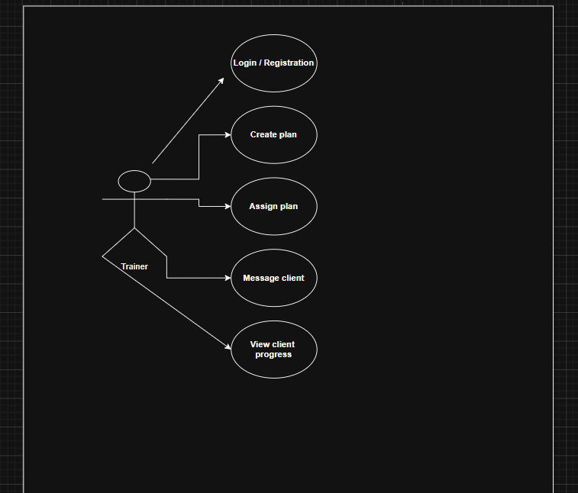

- Admin user case diagram

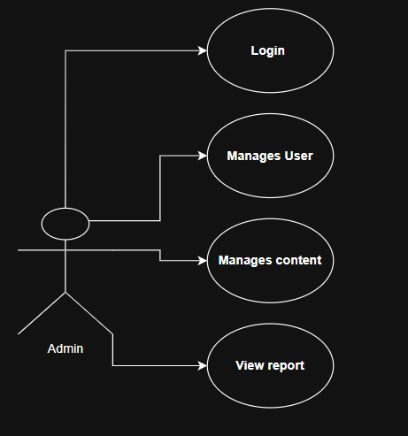

- Activity diagram
- Module 1 (Registration and login page)
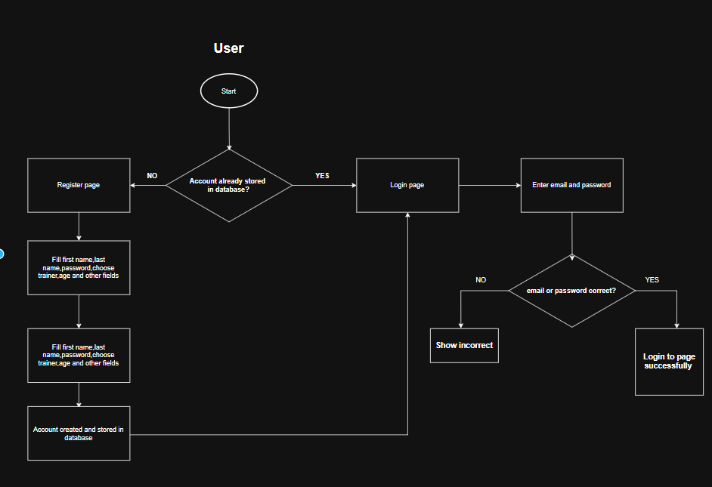

- Module 2 Create workout plan and mark exercise complete
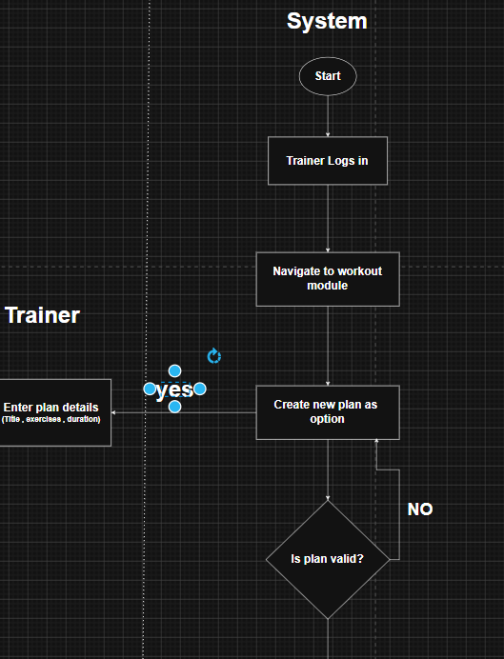
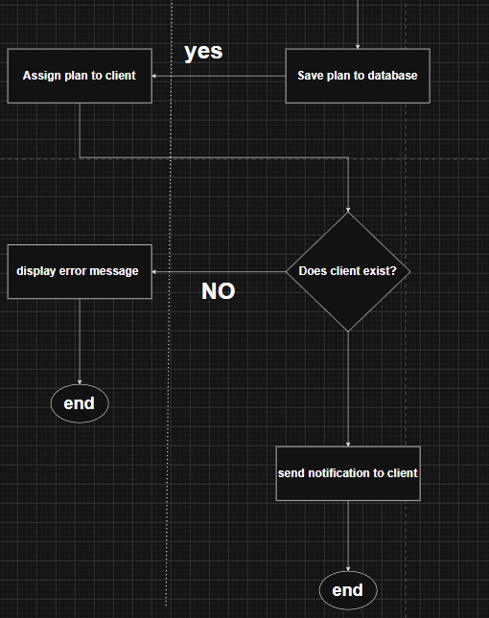

- Module 3 Create workout plan and mark exercise complete
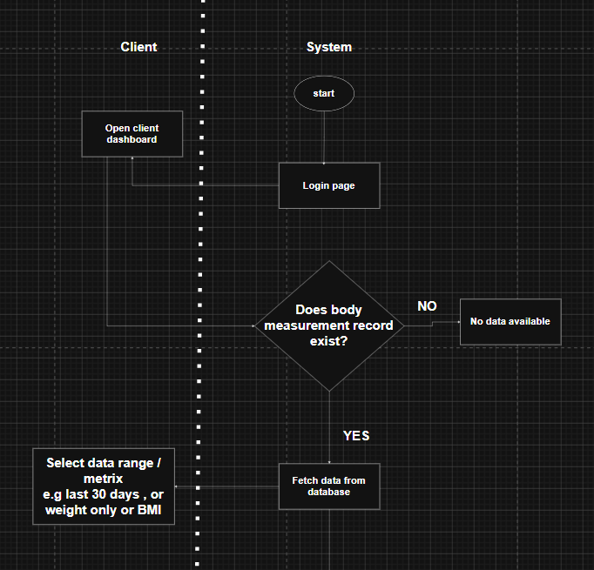
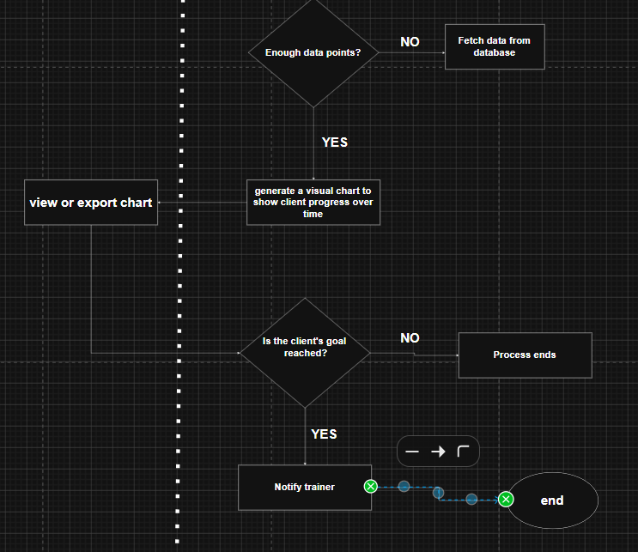

- Module 4 ( send message to trainer)
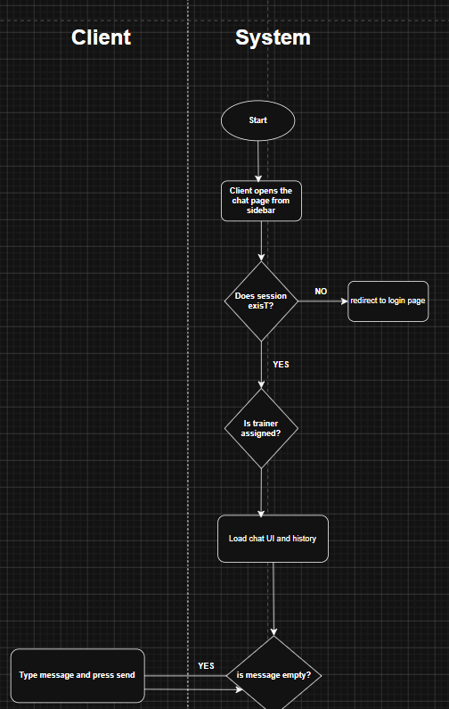
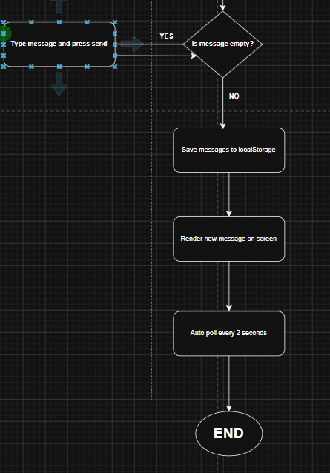

- Module 4 ( receive feedback from trainer )

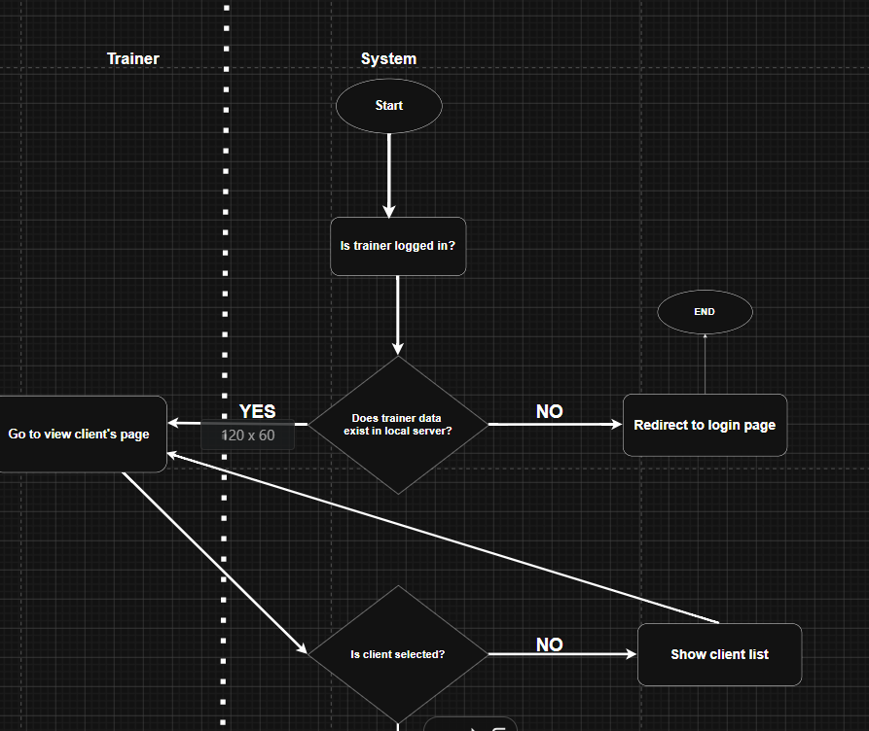
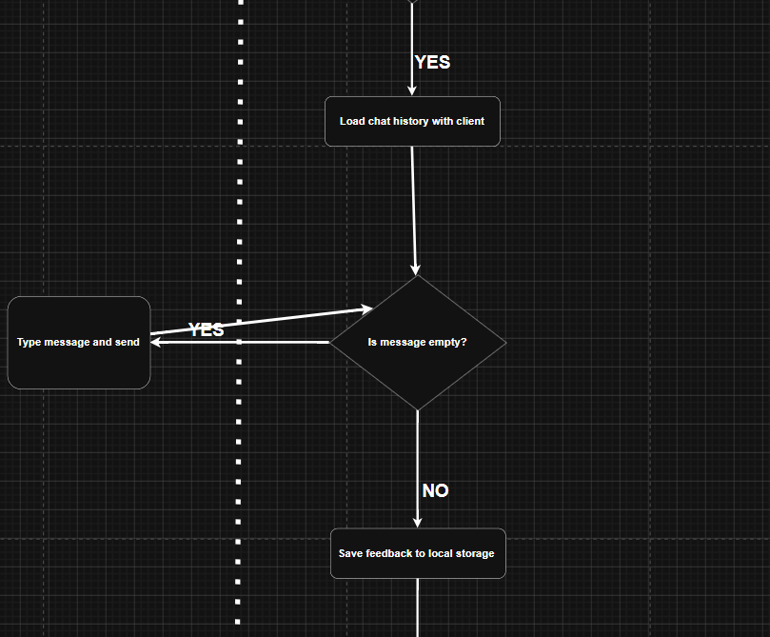
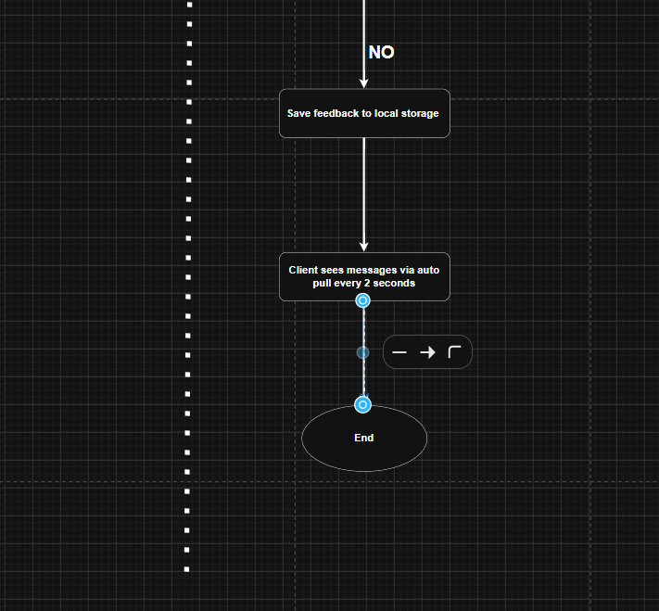

- Module 5 ( Log food daily intake and calorie tracker)
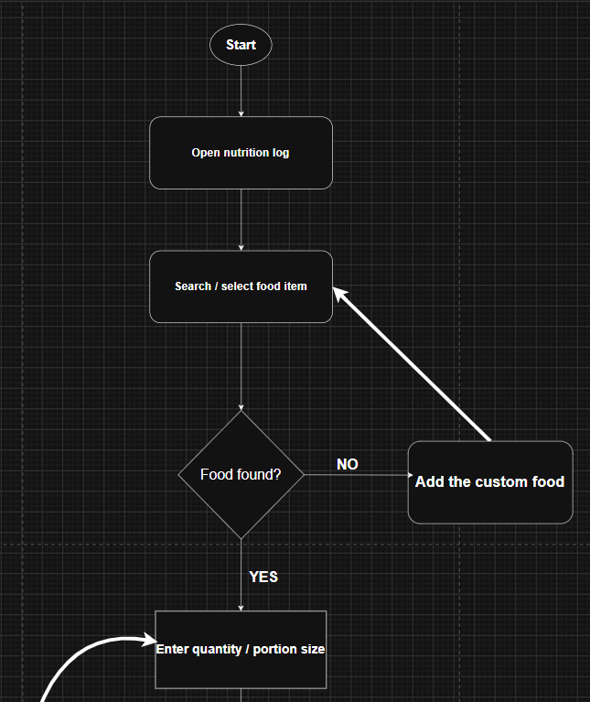
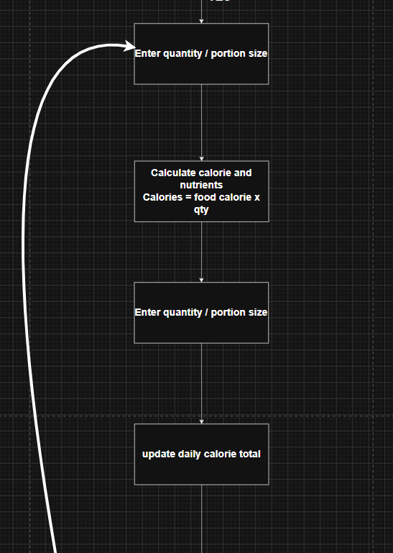
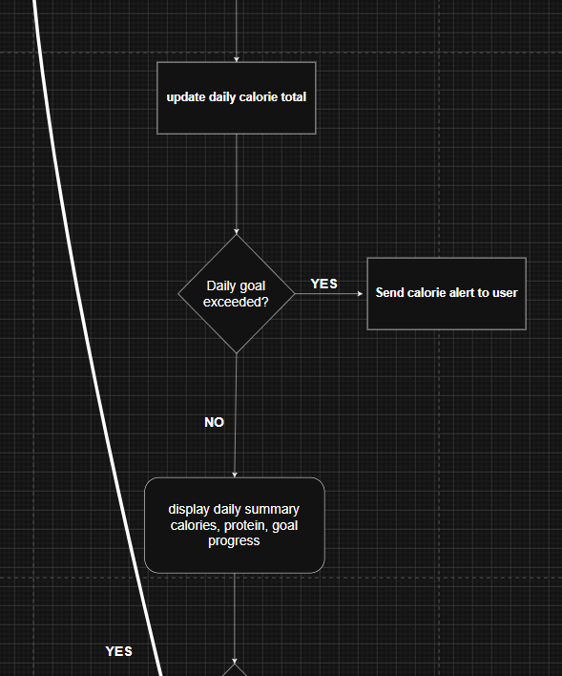
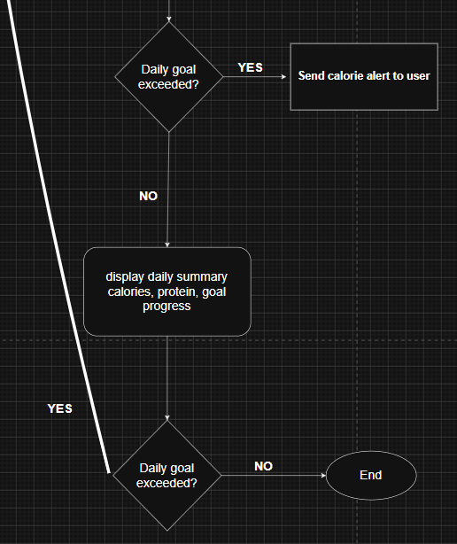

- Browse exercise tutorial module 6
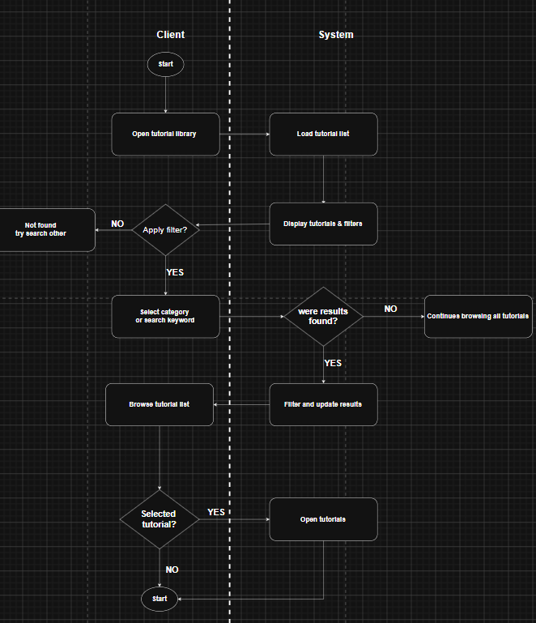

- Module 6 view tutorial video
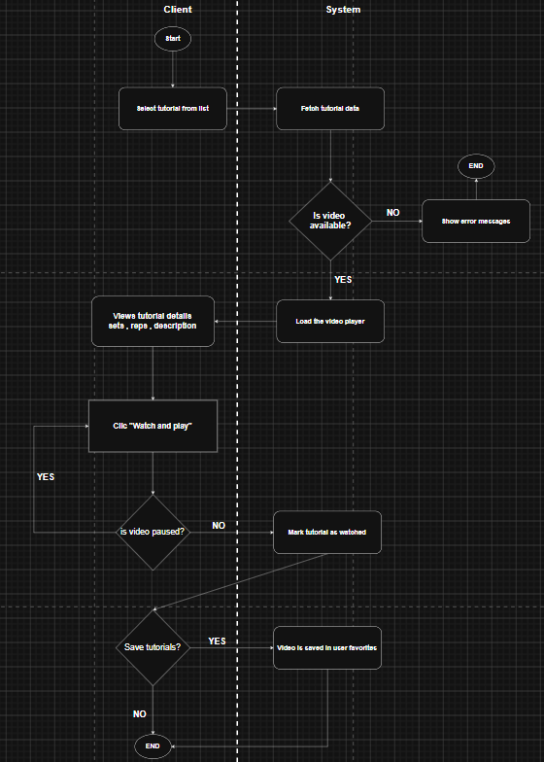

Class diagram-1 overall system

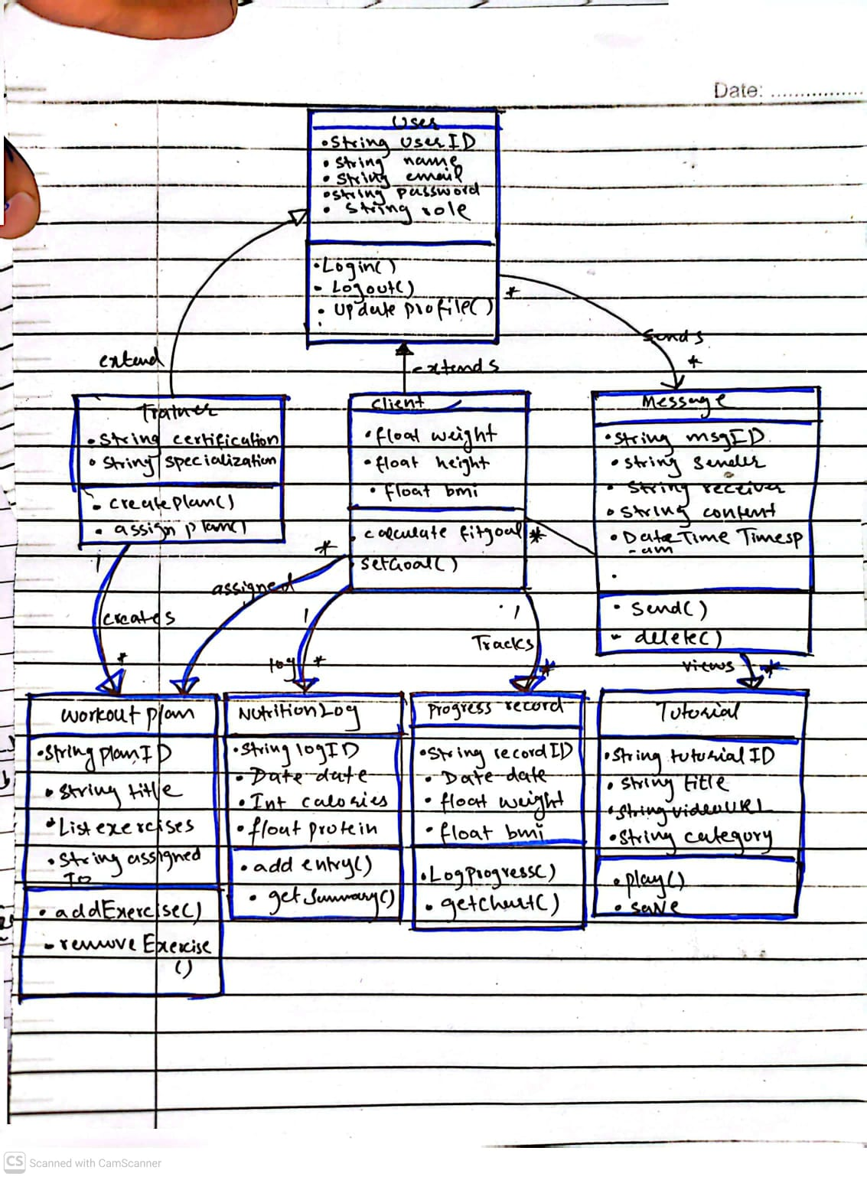

Sequence diagram

Registration page
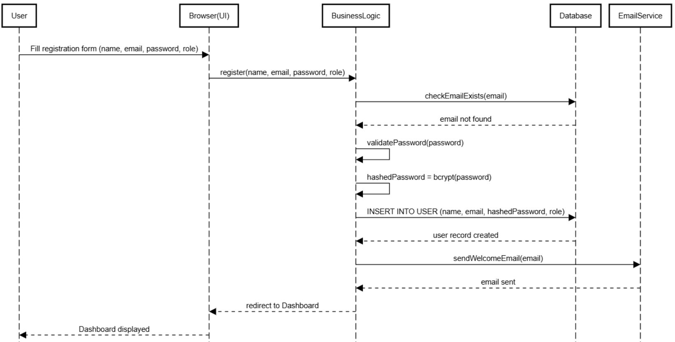
- User Logout
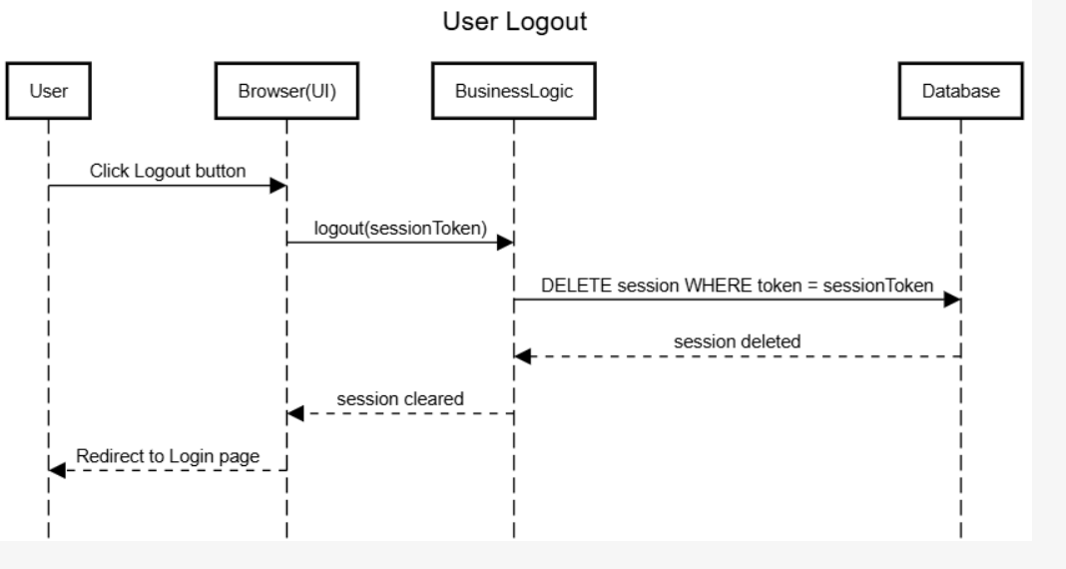

- Calculate BMI
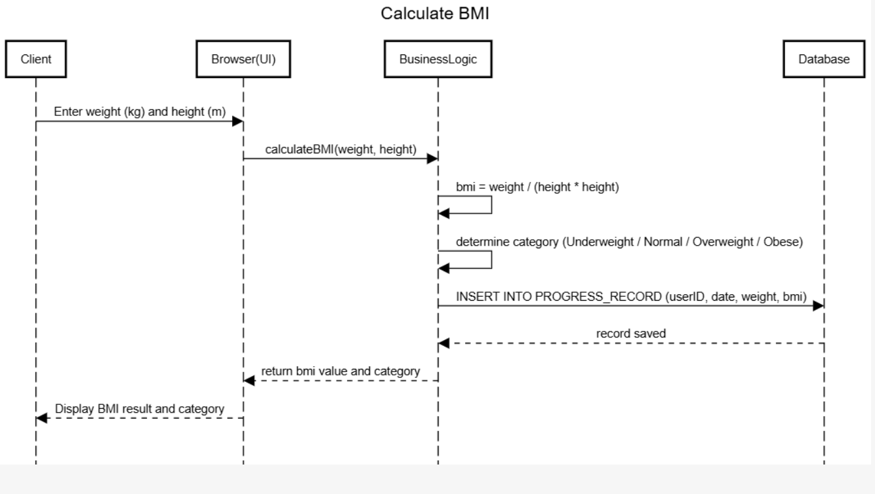

- Log body measurement and view progress
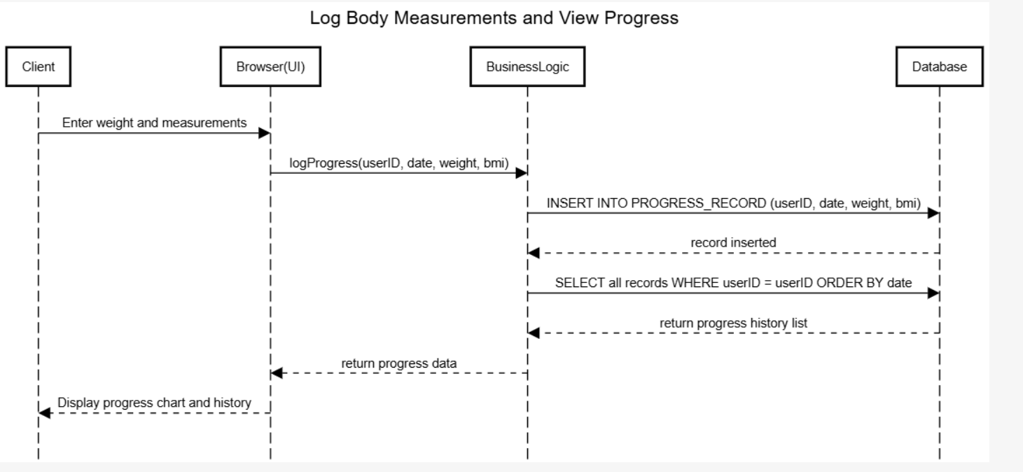

- Create workout Plan
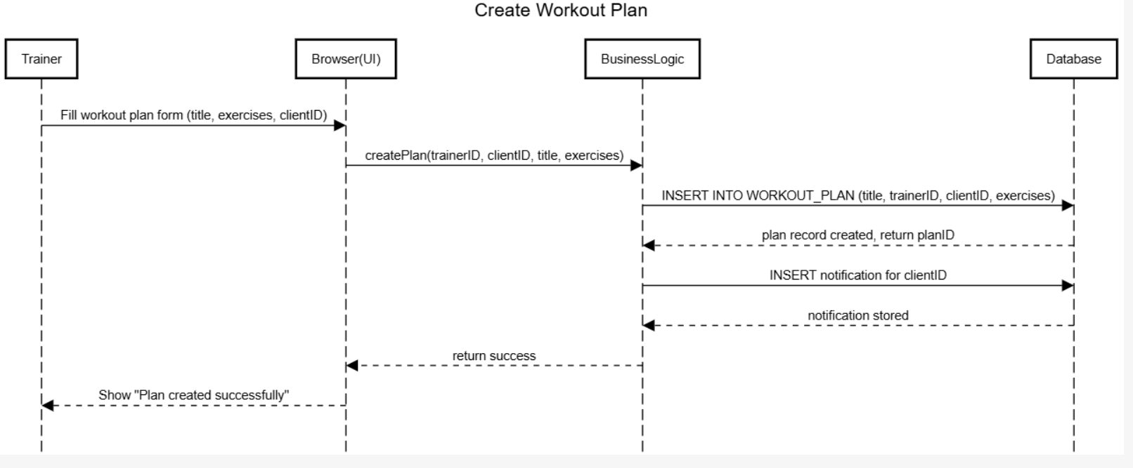

- Assign workout plan
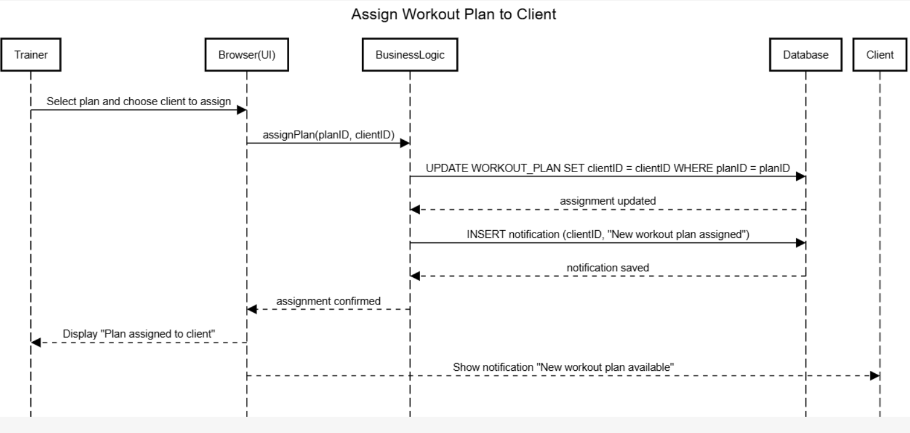

- Mark exercise as complete
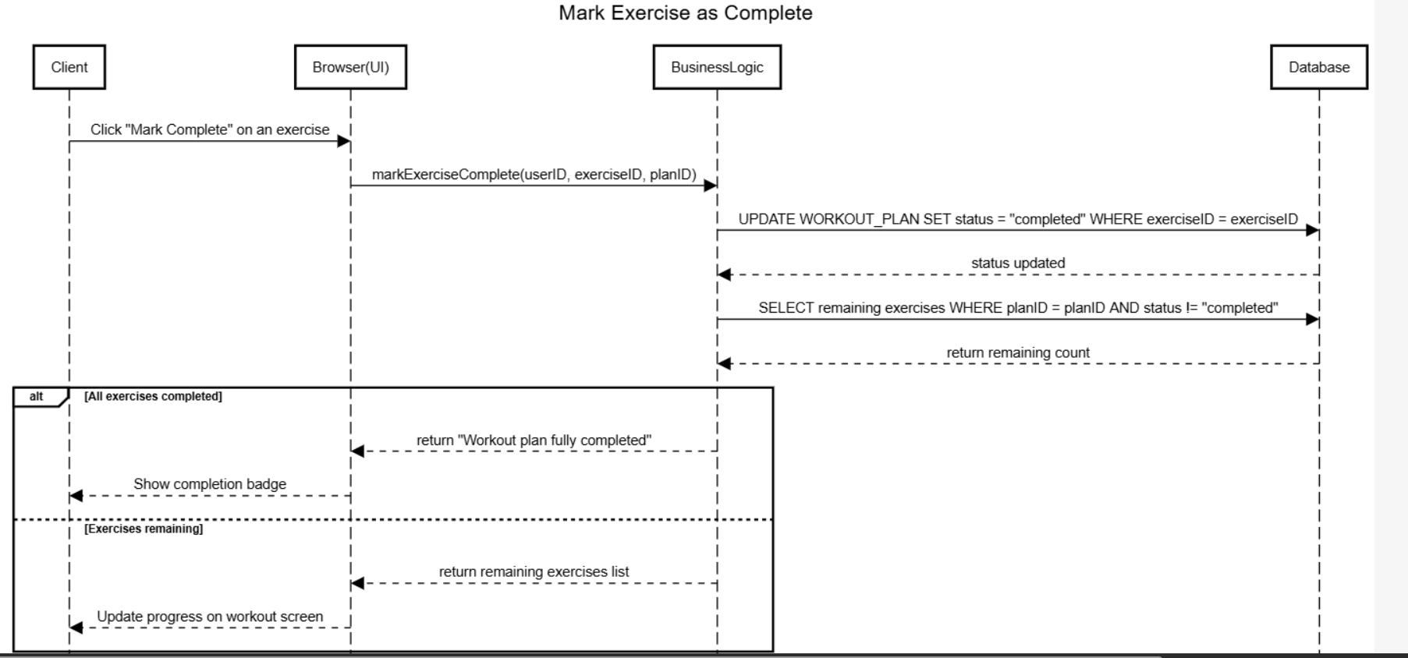

- Log daily calorie intake
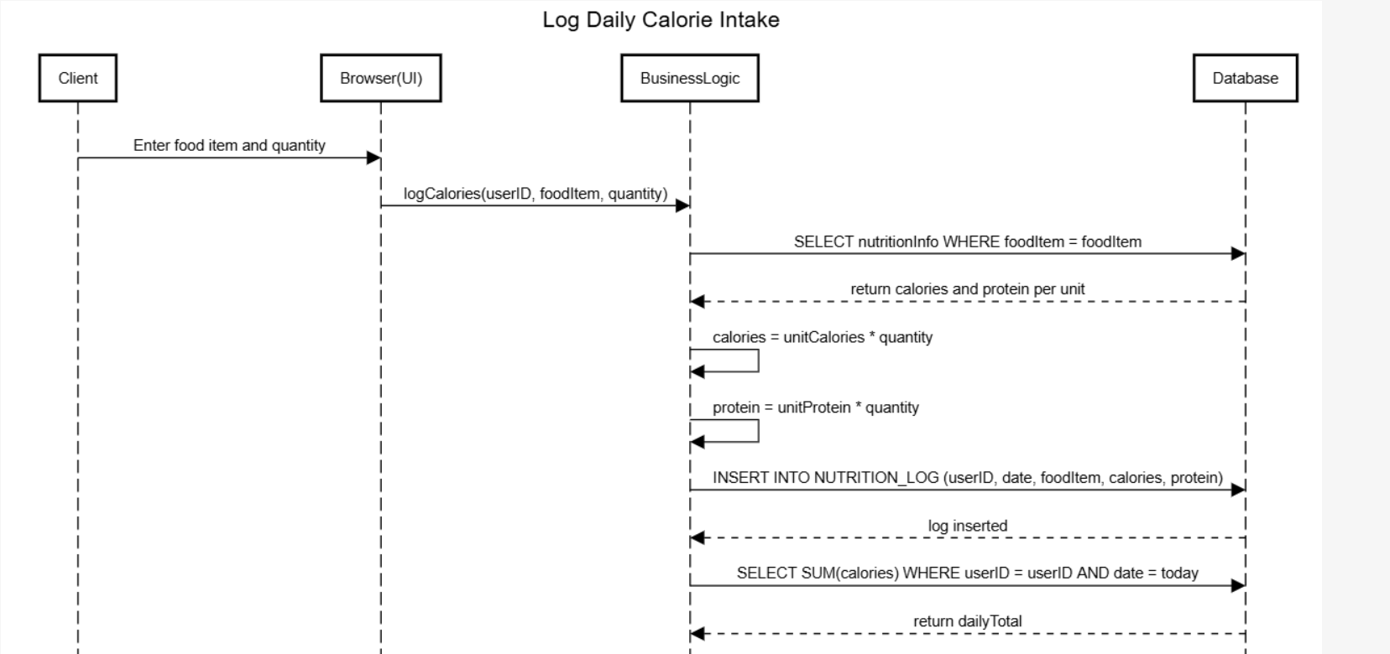
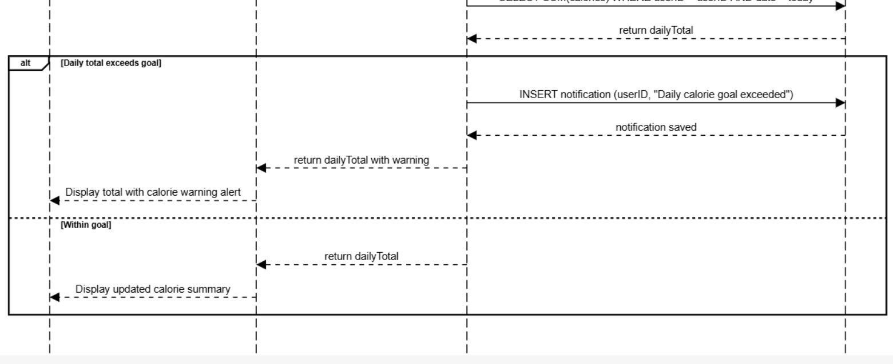

- Send message from client to trainer
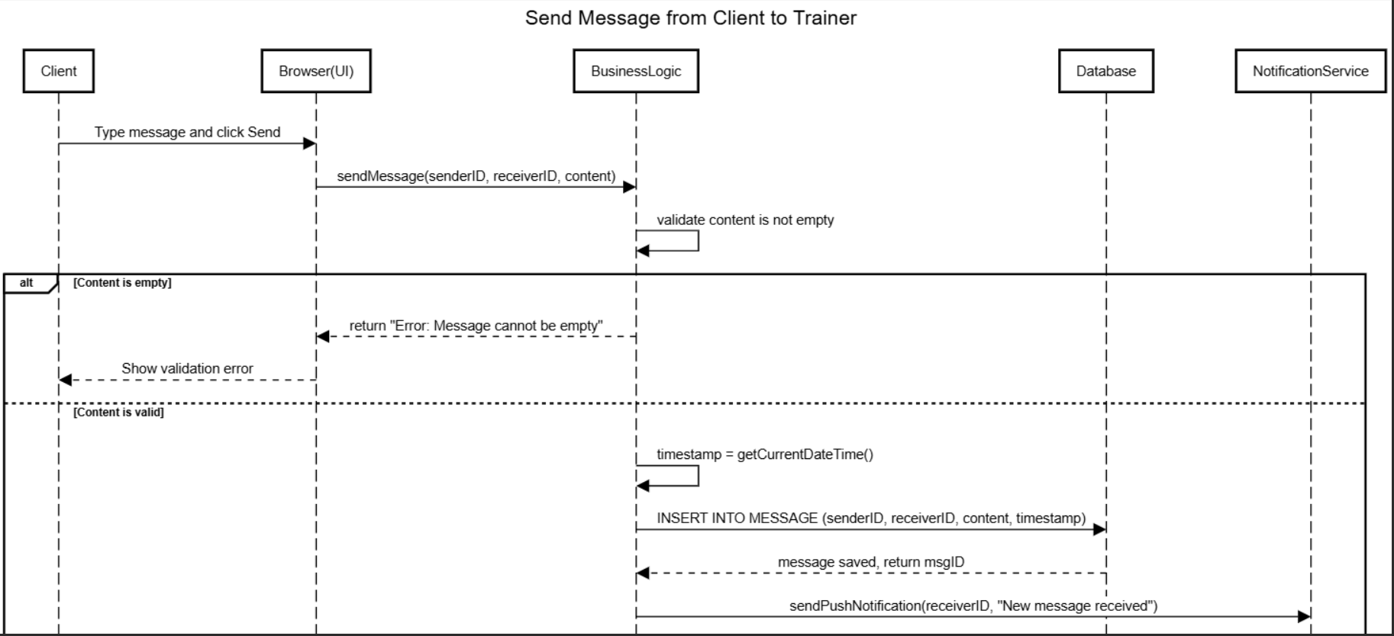
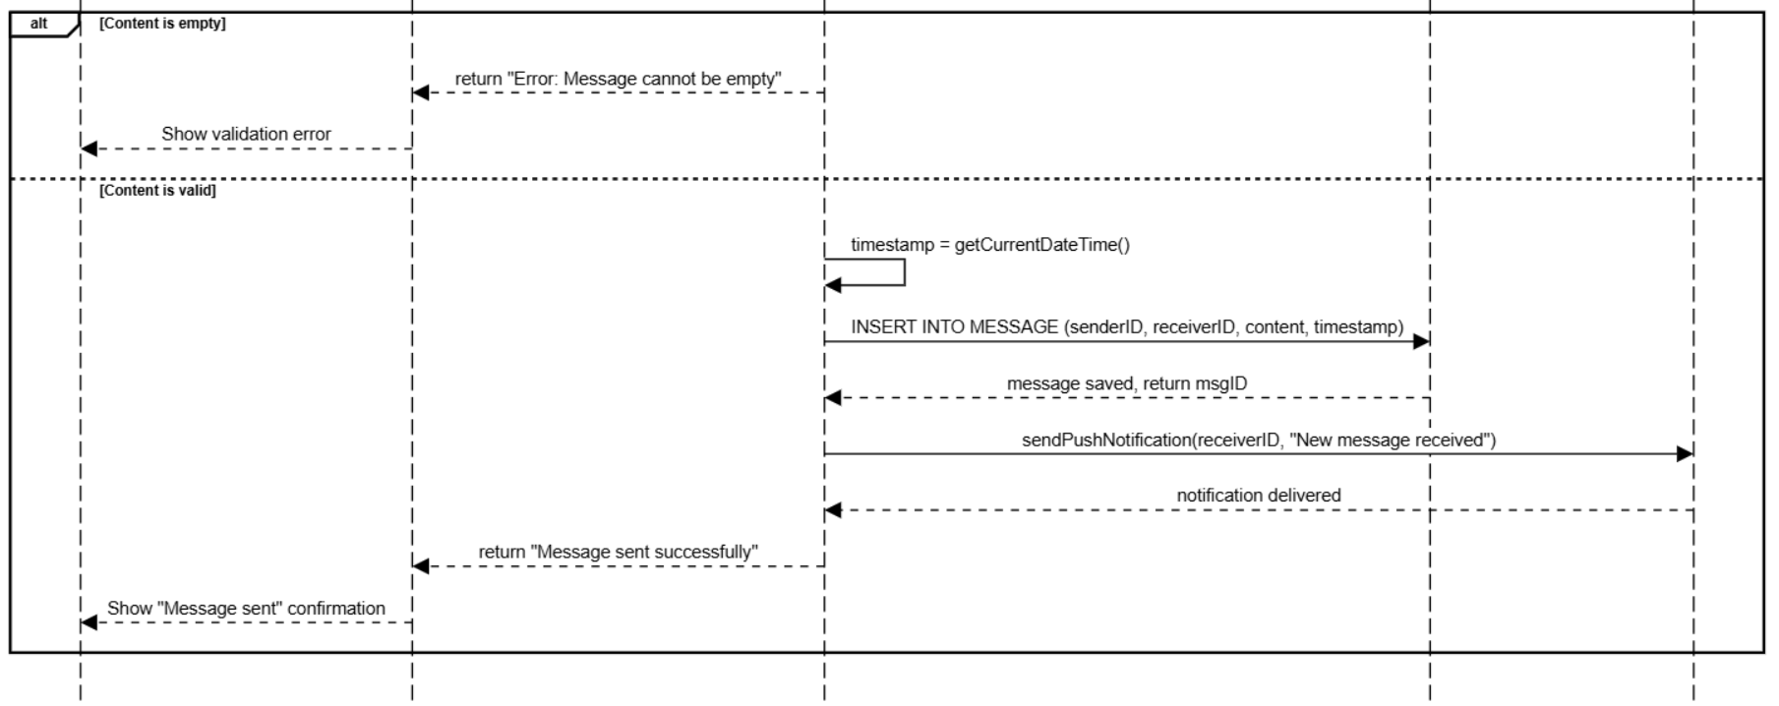
- Trainer provides feedback to client
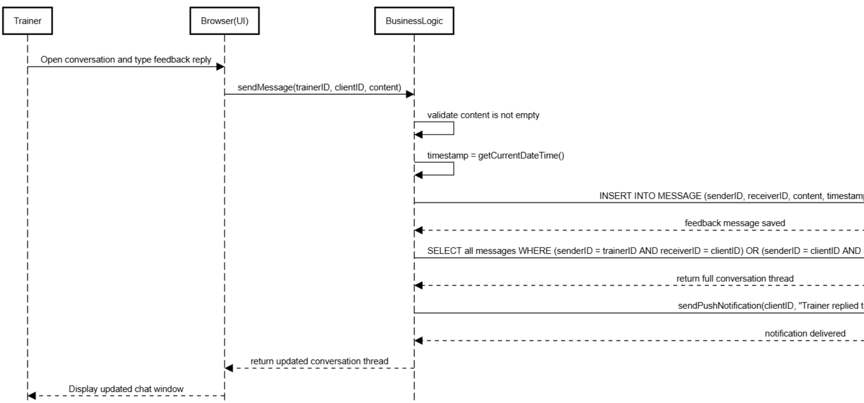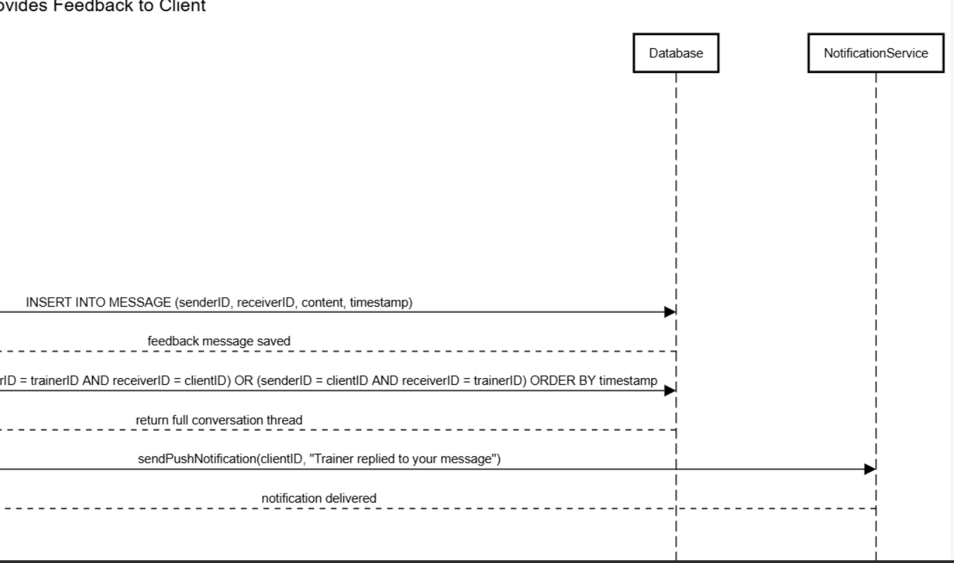

- Trainer provides feedback back to client
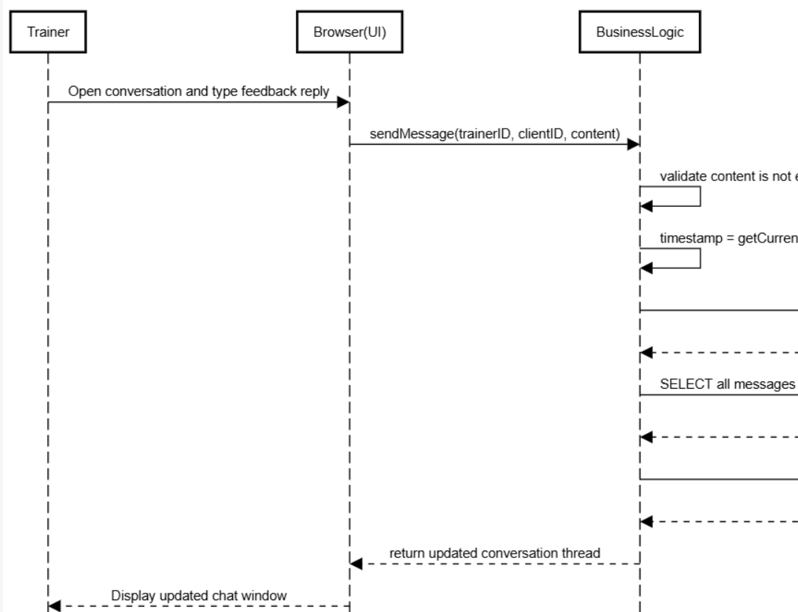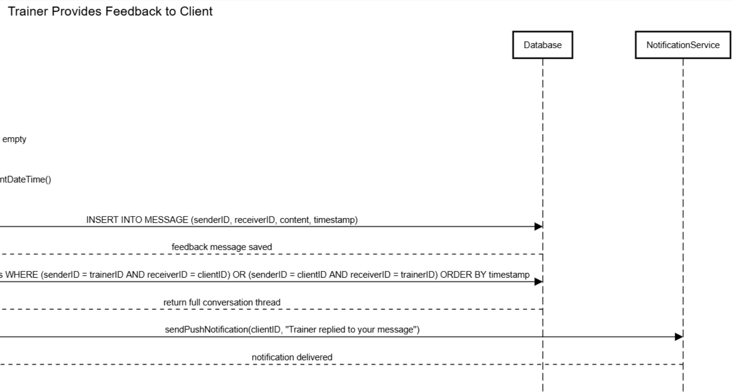

- Browse and watch exercise tutorial
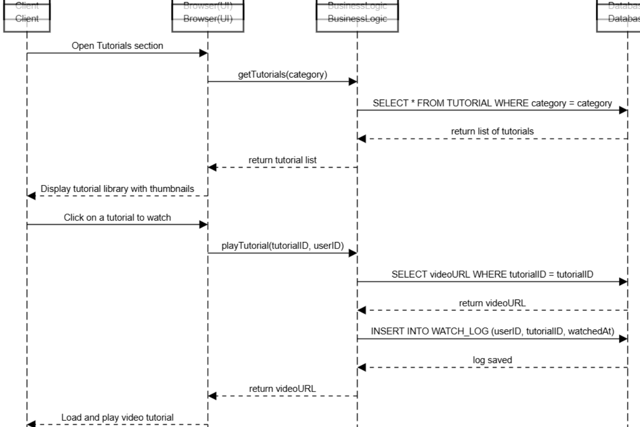

Modules View:

Dashboard:
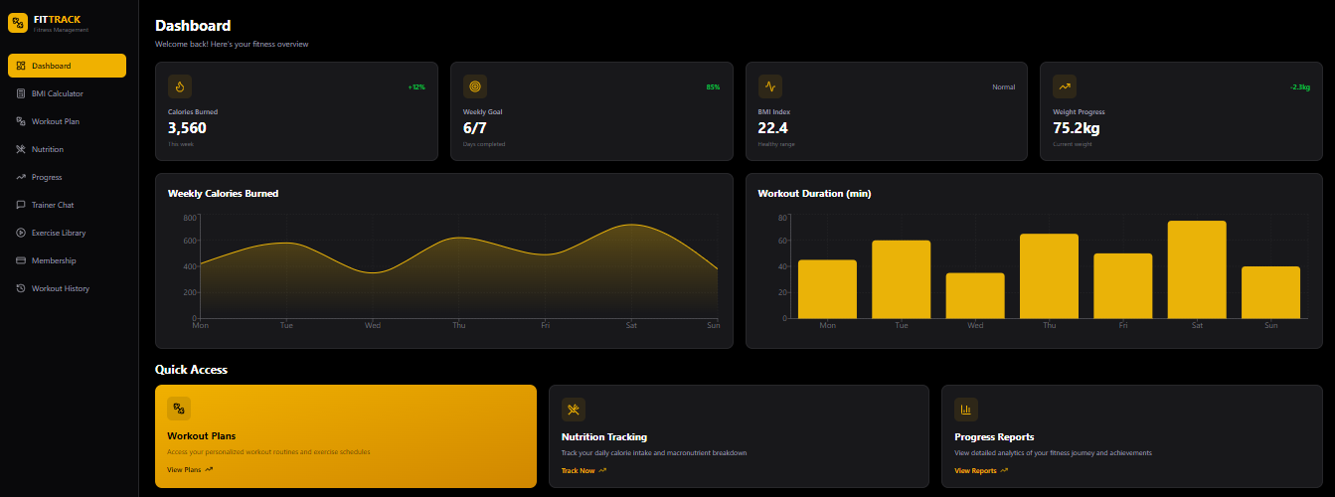

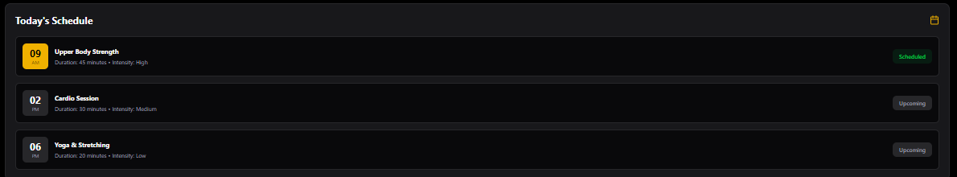

BMI Calculator:
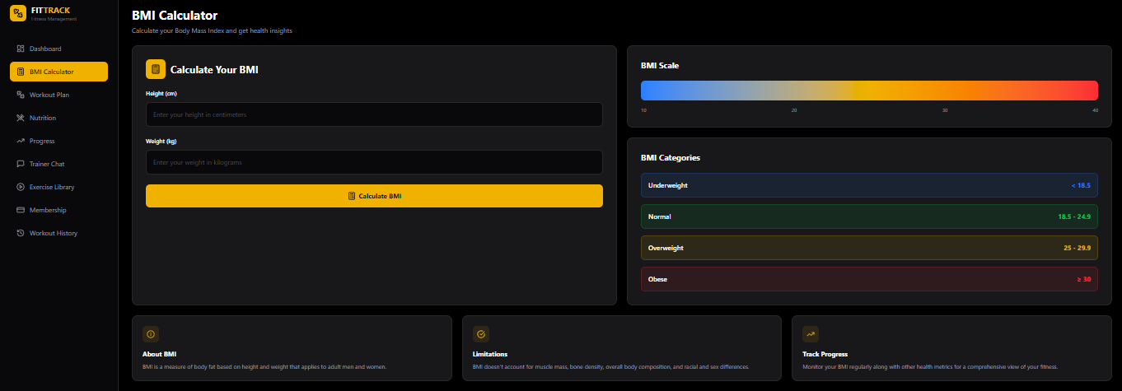

Workout Plan:
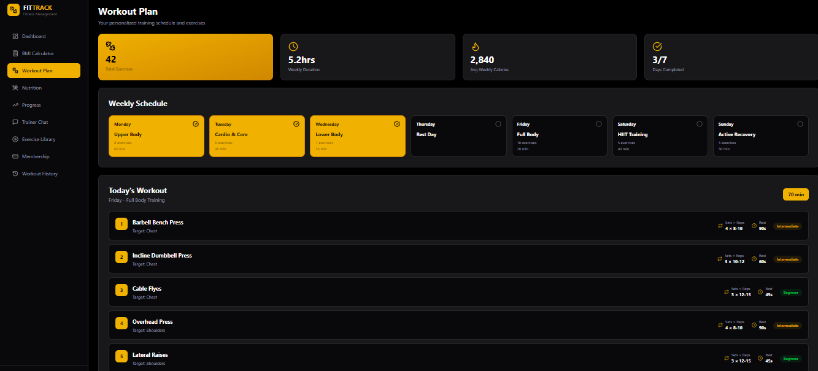

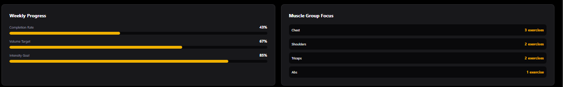

Nutrition:
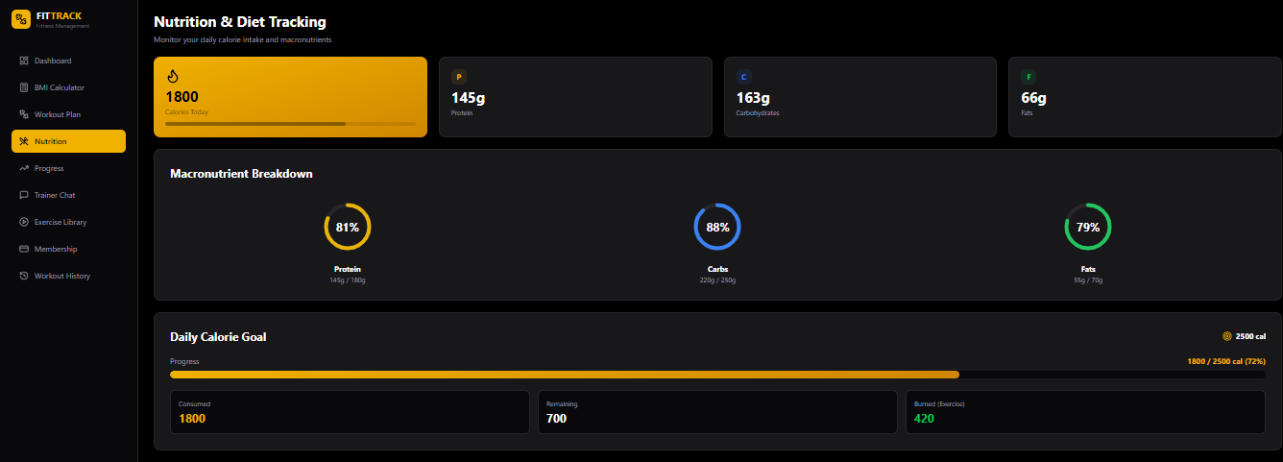

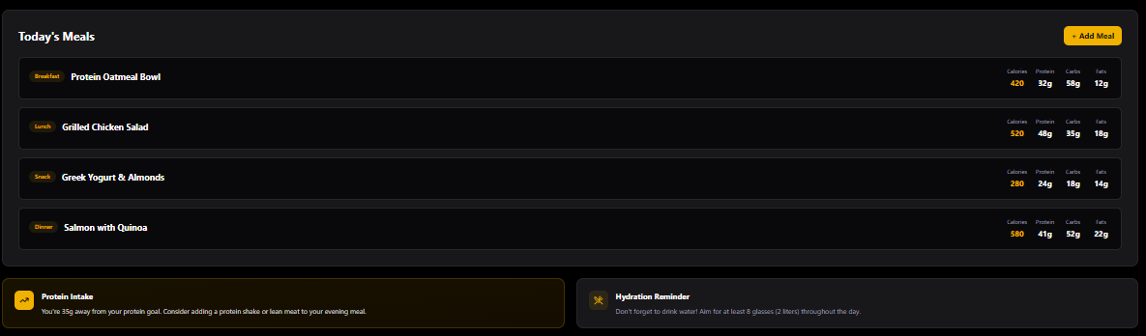

Progress:
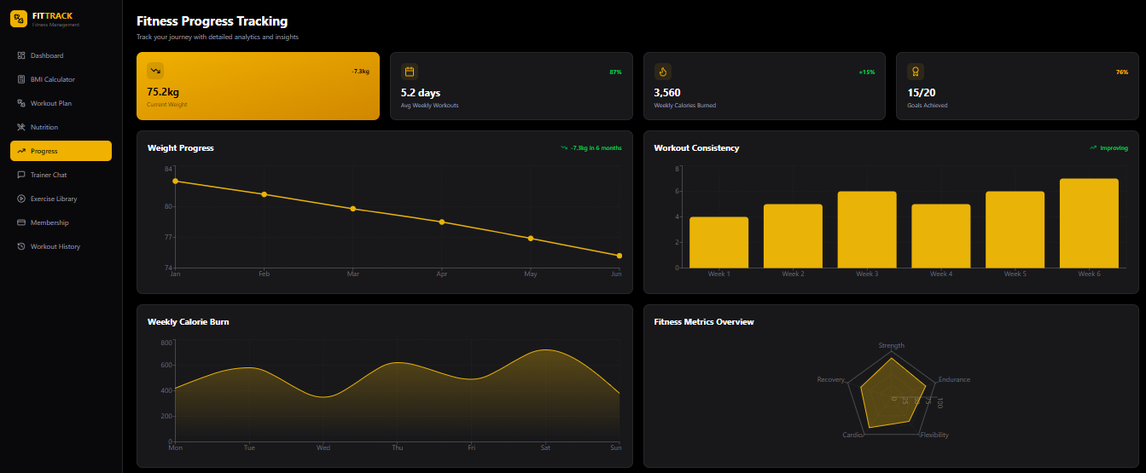

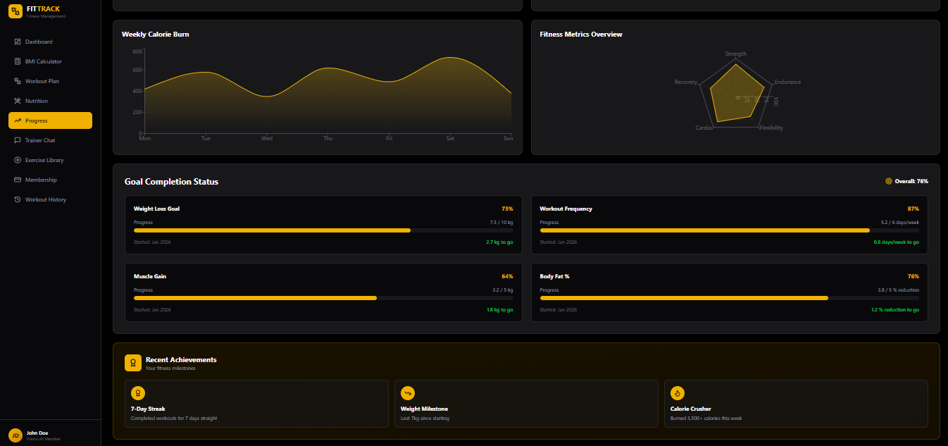

Trainer Chat:
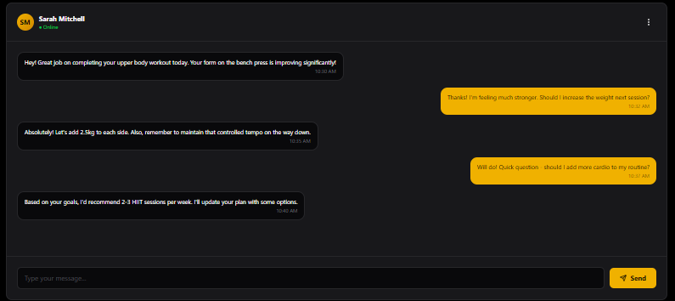

Exercise Library:
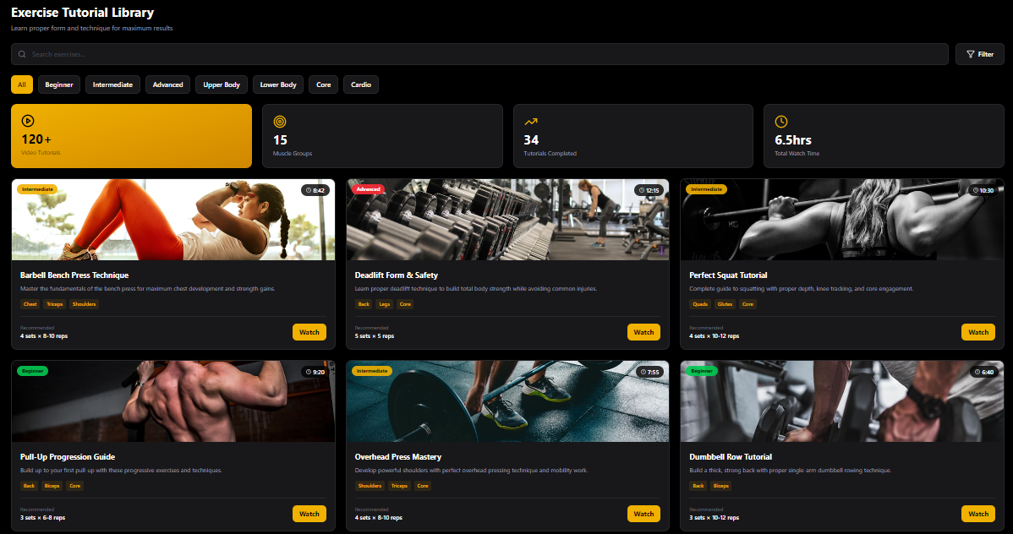

Workout History:
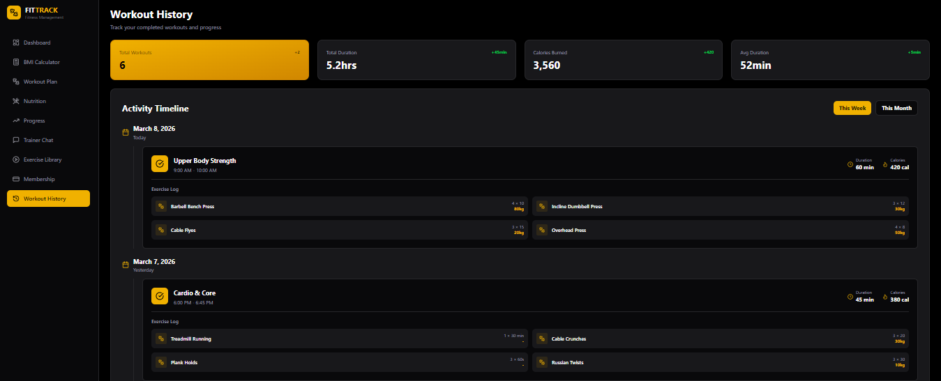

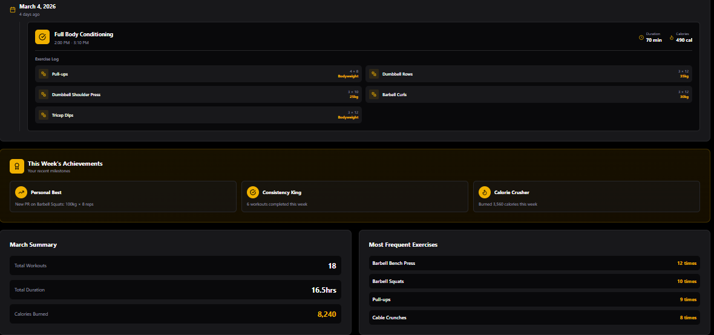

Data design
The system uses SQL relational database to store and manage all data. The major entities include User, Workout_plan , Nutrition Log , ProgressRecord , Message, and tutorial. Data is organized using primary and foreign keys to maintain relationships between entities and ensure data integrity.
- ER Diagram
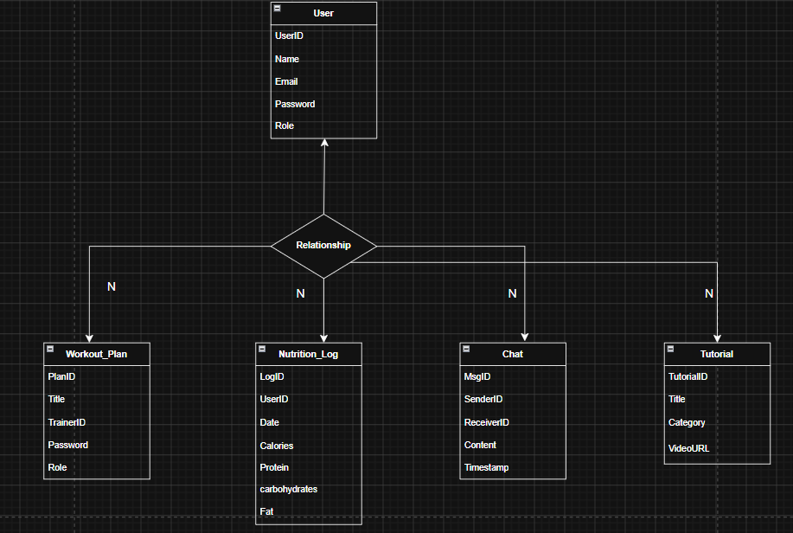

- Data dictionary table
Entity | Attribute | Data type | Description
chat | MsgID | int | Unique message identifier
chat | SenderiID | int | References UserID of sender
chat | ReceiverID | int | References UserID of receiver
chat | content | text | Text body of message
chat | Timestamp | DATETIME | Date and time message sent
NutritionLog | LogID | int | Unique log entry identifier
NutritionLog | UserID | int | Reference UserID of member
NutritionLog | Date | Date | Dte of nutrition entry
NutritionLog | calories | Decimal(6,2) | Total calorie intake for the day
NutritionLog | protein | Decimal(5,2) | Total protein intake
ProgressRecord | UserID | int | Reference UserID of member
ProgressRecord | Date | Date | Date the measurement was recorded
ProgressRecord | BMI | Decimal(4,2) | Calculated body mass index
Tutorial | Title | VACHAR(150) | Title/name of tutorial
Tutorial | TutorialID | int | Unique tutorial identofier
Tutorial | videoURL | VACHAR(255) | URL path to tutorial video
User | UserID | int | Unique idenitifer for each user
User | name | Vachar(100) | Full name of user
User | Email | VACHAR(100) | User’s unique email address
User | password | Vachar(255) | Hashed password for login
User | Role | ENUM(‘client,Trainer,Admin) | Defines user type in system
Workout_plan | PlanID | int | Unique workout plan identifer
Workout_plan | Title | Vachar(150) | Name / title of workout plan
Workout_plan | TrainerID | int | References UserID of trainer
Workout_plan | ClientID | int | References USERID of client

BMI Calculator Module:

Algorithm
- Start.
- Input height in centimeters and weight in kilograms.
- Convert height to meters: height\ m = height / 100.
- Calculate $BMI = weight / (height\ m^2).
- Determine category based on scale:
  - BMI < 18.5: Underweight
  - 18.5 – 24.9: Normal
  - 25.0 – 29.9: Overweight
  - BMI 30: Obese
- Output BMI value and category.
- End

PDL:
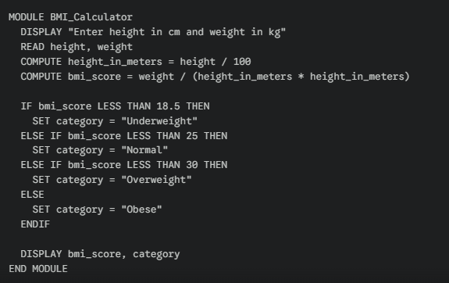

Pseudo Code:
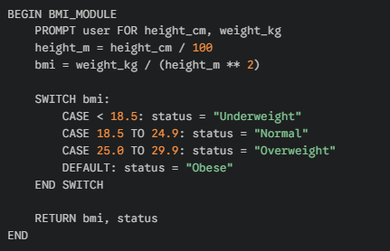

Nutrition Module:

Algorithm
- Start.
- Load Daily Goal (e.g., 2500 cal).
- Input Meal Data (Calories, Protein, Carbs, Fats).
- Update Total consume and specific macro totals.
- Calculate Remaining_Calories = Daily_Goal - Total_Consumed + Calories_Burned_from_Exercise.
- Calculate percentage completion for each macro.
- End.

PDL:
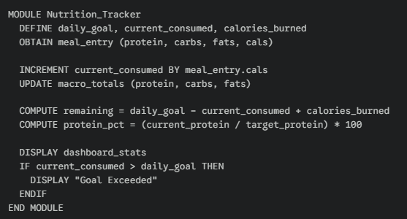

Pseudo Code:
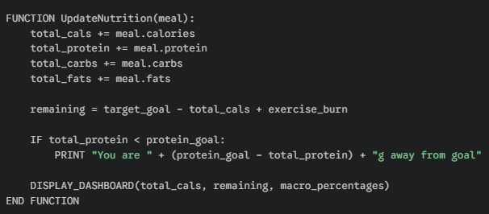

Workout Plan & History Module:

Algorithm
- Start.
- Load Weekly Schedule.
- If Day == today display Today's Workout (List of exercises, sets, reps).
- When exercise is completed, mark as Done.
- On workout completion, transfer data to Workout_History.
- Update Weekly_Progress metrics (Completion Rate, Volume).
- End.

PDL:
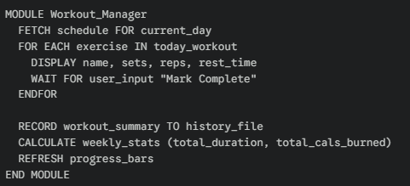

Pseudo Code:
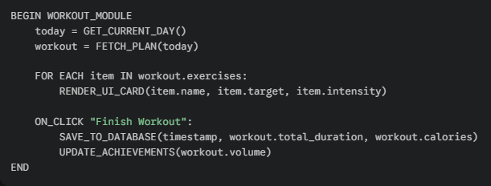

Trainer Chat Module:

Algorithm
- Start.
- Establish connection to Trainer_Server.
- Display message history.
- Input User_Message.
- Append User_Message to UI and send to server.
- On Receive_Message, update UI with trainer response and timestamp.
- End.

Pseudo Code
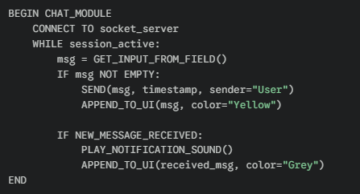

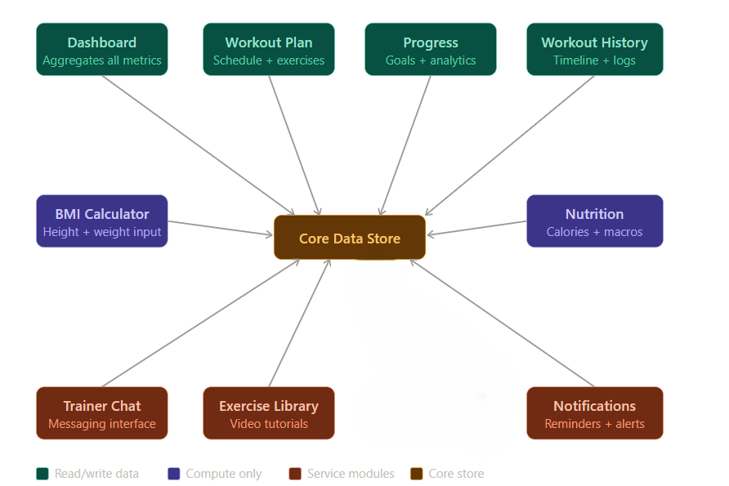

Closing section

Conclusion

This Software Design Description document presents a comprehensive design for the Gym Fitness and Workout Progress Tracking Portal. The system has been designed using Object-Oriented Design methodology and follows the Agile process model to ensure iterative and modular development. The design models including use case diagrams, activity diagrams, class diagrams, and sequence diagrams provide a thorough understanding of system behavior and module interactions. The data design ensures efficient storage and retrieval of all fitness-related data through a well-structured SQL database. This document serves as a complete blueprint for the implementation phase of the project

References
- Draw.io
- Vs code
- Figma
- Sequence diagram.org https://sequencediagram.org/

